SIMATS ENGINEERING

CSA15 – CLOUD COMPUTING AND BIG DATA ANALYTICS

ASSIGNMENT 3 – CO3
OBE-Based Evidence Principle

Design a Cloud-Based Collaborative Solution
CO3: Implement cloud-based solutions using cloud storage, web APIs, and platform services for real-world applications.

Field | Details | Field | Details
Student Name | PINDIBOINA SAI DEEPAK | Register Number | 192411047
Department / Section | CSE | Academic Year / Semester | 2026
Faculty Name | Dr Latha R | Nature of Assignment | Individual
Duration | 1 Week | Total Marks | 50
Submission Date | 5/11/2026 | Evaluation Date

MARK SHEET (Rubric-based evaluation)
Task | Title | Max | Awarded | Evidence / evaluation focus
1 | Accessing Cloud Services through Different Methods | 6 |  | Access-method diagram; demonstration; screenshots; comparison
2 | Cloud Platforms and Web Applications | 7 |  | Two platforms; interaction diagram; app demonstration; evaluation
3 | Web APIs for Cloud Access | 7 |  | API design; executable client; two requests; responses
4 | Cloud Security and Network Access | 7 |  | Secure-access architecture; threats; authentication; mitigations
5 | Collaboration Using Cloud-Based Services | 6 |  | Shared workspace; permissions; edits; contribution evidence
6 | Integrated Cloud Access and Collaboration Mini Investigation | 7 |  | Scenario; architecture; prototype; two user tests; evaluation
7 | Day-4 Design Challenge: Cloud-Based Collaborative Solution | 10 |  | Two independent proposals; comparison; joint design; validation; defence
 | TOTAL | 50 |  | Percentage:

OVERALL REMARKS

_______________  Student Signature | _______________  Faculty Signature | _______________  Program Director

MANDATORY SUBMISSION EVIDENCE CHECK

✓ = Present in documented answer; P = Partly present; ✗ = Missing / not satisfied
Task | Evidence expected | Status | Evaluator note
1 | Three access methods, client–network–cloud diagram, demonstration and observations |  | Access-method classification and practical access screenshots to be checked.
2 | Two-platform comparison, interaction diagram and cloud web-app demonstration |  | Platform mapping, user-action sequence and local-versus-cloud evaluation to be checked.
3 | API flow, program, two request inputs, responses and execution evidence |  | Code, actual request/response outputs and analysis to be checked.
4 | Secure-access flow, four security considerations, threat and mitigation analysis |  | Authentication, authorization and secure-communication evidence to be checked.
5 | Shared workspace, permission settings, two collaborative activities and contributions |  | Verify shared editing, user roles, permissions and contribution screenshots.
6 | Integrated scenario, architecture, prototype, two user scenarios and results |  | Verify cloud access, collaboration workflow, tests and limitations.
7 | Two initial proposals, comparison record, joint design, tests and cross-defence |  | Verify independent proposals, joint decisions, observed results and both students’ understanding.

IMPLEMENTATION EVIDENCE CHAIN
Evidence item | Status | Observation
Cloud access methods |  | Browser, mobile and API access methods explained.
Cloud platforms |  | Two cloud platforms and their applications compared.
Cloud access demonstration |  | Actual screenshots need verification.
Web API implementation |  | Program and execution outputs need verification.
Cloud security |  | Authentication, authorization and security measures explained.
Cloud collaboration |  | Shared workspace and editing evidence need verification.
Mini-project |  | Design included; practical testing needs verification.
Day-4 design challenge |  | Individual proposals, joint design and validation need verification.
Student contributions |  | Contributions of both students need confirmation.
Screenshots |  | Original execution screenshots required.

SUBMISSION CHECKLIST (Not Separately Marked)
Requirement | Status
All 7 questions answered | ☐ Yes ☐ Partly ☐ No
Cloud access methods explained | ☐ Yes ☐ Partly ☐ No
Cloud architecture diagrams included | ☐ Yes ☐ Partly ☐ No
Two cloud platforms compared | ☐ Yes ☐ Partly ☐ No
Web API program and testing completed | ☐ Yes ☐ Partly ☐ No
Cloud security explained | ☐ Yes ☐ Partly ☐ No
Cloud collaboration demonstrated | ☐ Yes ☐ Partly ☐ No
Mini-project completed and tested | ☐ Yes ☐ Partly ☐ No
Day-4 design challenge completed | ☐ Yes ☐ Partly ☐ No
Student A and B contributions recorded | ☐ Yes ☐ Partly ☐ No
Screenshots and practical evidence attached | ☐ Yes ☐ Partly ☐ No
Viva recommended | ☐ Yes ☐ No

CLOUD COMPUTING AND BIG DATA ANALYTICS
ASSIGNMENT 3 – CO3

CO3: Implement cloud-based solutions using cloud storage, web APIs, and platform services for real-world applications.

Mode: Pair Work – 2 Students per Group
Duration: 1 Week Total Marks: 50

OBE-Based Evidence Principle

The assignment requires students to demonstrate measurable evidence of:
Understand → Design → Implement → Demonstrate → Analyse → Evaluate
Both students must understand the complete assignment. Students should not simply divide questions between them. Individual responsibilities are assigned within each question so that the contribution and attainment of CO3 can be independently verified.

Q1 – Accessing Cloud Services through Different Methods 6 Marks
Shared Group Work
Together, the pair must:
- Identify different methods of accessing cloud services.
- Study browser-based/cloud console access.
- Study access through mobile applications.
- Study access through APIs.
- Identify the role of Internet/network connectivity.
- Select one suitable cloud service for demonstration.
Student A – Access Method Design
Student A must individually:
- Identify and classify at least three cloud access methods.
- Prepare a simple architecture/flow diagram showing:
Client → Network → Cloud Service
- Explain how a user accesses the selected cloud service.
- Identify the hardware/software requirements.
- Explain the role of the client and network.
- Justify which access method is most suitable for the selected application.
Student B – Practical Evidence
Student B must individually:
- Demonstrate access to a cloud service using one selected method.
- Record the steps/screenshots as evidence.
- Test the access using different devices or access methods where possible.
- Record observations such as accessibility, response, and usability.
- Identify one limitation encountered during access.
- Explain how the limitation can affect cloud usage.
Cross-Verification
Student A must be able to explain Student B's practical demonstration.
Student B must be able to explain Student A's access architecture.
Evidence Expected: Architecture diagram + screenshots/observations + comparison.

Q2 – Cloud Platforms and Web Applications 7 Marks
Shared Group Work
Together:
- Select two cloud platforms/services.
- Identify the web applications available through them.
- Study how users interact with the applications.
- Identify the cloud resources/services supporting the application.
- Prepare a comparative observation.
Student A – Platform Analysis
Student A must individually:
- Identify the major components of the selected cloud platform.
- Explain how the platform supports web applications.
- Map the user request to the cloud service.
- Explain the role of the Internet, server/cloud infrastructure and application.
- Prepare a simple interaction diagram.
Student B – Application Investigation
Student B must individually:
- Select one real-world cloud-based web application.
- Demonstrate its major functions.
- Record the sequence of user actions.
- Identify where cloud access is involved.
- Collect screenshots/evidence of the demonstration.
- Analyse the benefits of using the cloud-based application.
Joint Evaluation
Together answer:
If the same application were installed and operated only on a local computer, what limitations might users experience compared with accessing it through the cloud?
Evidence Expected: Platform/application mapping + demonstration evidence + evaluation.

Q3 – Web APIs for Cloud Access 7 Marks
Shared Group Work
Together:
- Study the concept of a Web API.
- Identify how APIs enable application-to-cloud communication.
- Select a simple publicly accessible API or cloud API.
- Develop a small program/client to send a request.
- Observe and record the response.
Student A – API Design and Understanding
Student A must individually:
- Explain the purpose of the selected API.
- Identify the request and response components.
- Represent the API communication using a flow diagram.
- Explain the role of:
  - Client
  - API request
  - Cloud/server
  - API response
- Explain how APIs enable programmatic cloud access.
Student B – Implementation and Evidence
Student B must individually:
- Implement a simple API request using Python or another suitable language.
- Execute the program.
- Record input/request and output/response.
- Test at least two different requests or inputs.
- Capture execution evidence.
- Analyse the observed results.
Joint Analysis
Together determine:
Why is API-based access useful when a large number of users/applications need to communicate with a cloud service automatically?
Evidence Expected: Program + execution screenshots + request/response evidence + analysis.

Q4 – Cloud Security and Network Access 7 Marks
Shared Group Work
Together:
- Identify security issues involved in accessing cloud services.
- Study authentication and authorization.
- Study secure network communication.
- Identify possible threats during cloud access.
- Prepare a secure cloud-access scenario.
Student B – Security Design
Student B must individually:
- Identify at least four security considerations for cloud access.
- Explain authentication and authorization.
- Explain the importance of secure communication.
- Design a secure access flow:
User → Authentication → Network → Cloud Service → Authorization → Resource
- Identify possible points of attack.
- Suggest suitable security measures.
Student A – Security Investigation
Student A must individually:
- Investigate a practical cloud-access security scenario.
- Demonstrate or document a suitable authentication mechanism where feasible.
- Compare secure and insecure access situations conceptually.
- Record observations.
- Explain how poor security practices can affect cloud users and data.
Joint Evaluation
Together answer:
If cloud access is available from anywhere through the Internet, what additional security measures are necessary compared with a local application?
Evidence Expected: Secure-access architecture + threat identification + mitigation analysis.

Q5 – Collaboration Using Cloud-Based Services 6 Marks
Shared Group Work
Together:
- Select a cloud collaboration platform/service.
- Create a shared document/folder/project space.
- Configure appropriate sharing permissions.
- Perform collaborative editing.
- Record the collaboration process.
Student A – Collaboration Design
Student A must individually:
- Identify the collaboration requirements.
- Design a suitable cloud collaboration workflow.
- Explain:
  - Sharing
  - Concurrent access
  - Version control
  - Permission management
- Identify the roles of different users.
- Justify the selected sharing permissions.
Student B – Collaborative Implementation
Student B must individually:
- Participate in the shared cloud workspace.
- Perform at least two collaborative activities.
- Record evidence of contribution.
- Demonstrate sharing/permission settings.
- Observe how changes made by users are reflected.
- Identify one collaboration issue and suggest a solution.
Cross-Understanding
Student B must explain:
How does cloud collaboration reduce the need to exchange multiple copies of the same file?
Student A must explain:
What problems can occur if incorrect sharing permissions are given?
Evidence Expected: Shared workspace + contribution evidence + permission screenshots + observations.

Q6 – Integrated Cloud Access and Collaboration Mini Investigation 7 Marks
Students must design a small real-world scenario that requires both cloud access and cloud collaboration.
Suggested Scenarios
Choose one:
- Cloud-based Student Project Management
- Online Student Attendance and Faculty Collaboration
- Cloud-Based Event Management
- Cloud-Based Assignment Submission and Evaluation
- Cloud-Based Hospital Appointment Coordination
- Cloud-Based Disaster Information Sharing
- Cloud-Based College Placement Coordination
Student A – System Design
Student A must individually:
- Define the problem.
- Identify users.
- Identify cloud access methods.
- Identify required cloud services.
- Design the system architecture.
- Explain how users access the system.
- Explain how users collaborate.
Student B – Evidence and Evaluation
Student B must individually:
- Develop a small prototype/mock-up/workflow where feasible.
- Demonstrate at least one cloud access mechanism.
- Demonstrate one collaboration mechanism.
- Record screenshots/evidence.
- Test the proposed solution using at least two user scenarios.
- Analyse the results.
- Identify limitations and possible improvements.
Joint Evaluation
Together answer:
How does combining cloud access and cloud collaboration improve the efficiency of the proposed system?

Q7 – DAY-4 DESIGN CHALLENGE

Design a Cloud-Based Collaborative Solution 10 Marks

This question must be solved collaboratively.

Neither student should independently prepare the complete solution and combine it later.

Stage 1 – Independent Design Proposal
Before discussing with each other:
Student A independently proposes:

- Problem definition
- Target users
- Cloud access method
- Required cloud services
- Collaboration mechanism
- Basic architecture
Student B independently proposes:

- Problem definition
- Target users
- Cloud access method
- Required cloud services
- Collaboration mechanism
- Basic architecture
Both initial proposals must be retained as evidence.

Stage 2 – Compare the Two Designs

Together discuss:
- Where the designs agree
- Where they differ
- Strengths and weaknesses
- Security concerns
- Accessibility
- Collaboration requirements
- Missing components
- Which ideas should be retained
Prepare a Design Comparison Record.

Stage 3 – Joint Final Design
Develop the final cloud-based solution.
The final design must identify:
- Problem
- Users
- Cloud access method
- Network requirements
- Cloud service/platform
- Web application/API requirement
- Collaboration mechanism
- Authentication/security
- Data/resource sharing
- Complete system workflow
Prepare an architecture such as:

Users → Client → Internet/Network → Cloud Platform → Application/API → Shared Resources

Stage 4 – Validation

Student A – Technical Validation

Student A must:
- Explain the selected cloud access method.
- Justify the platform/service selection.
- Explain the system architecture.
- Explain how API/web access is used, if applicable.
- Analyse the suitability of the design.

Student B – Experimental Validation

Student B must:
- Design test cases.
- Demonstrate the solution/workflow.
- Test different users/access conditions.
- Record observations.
- Present screenshots or other evidence.
- Compare expected and observed behaviour.

Stage 5 – Cross-Defence

Student A must explain:
What experimental evidence supports the group's cloud design?

Student B must explain:
Why was the selected cloud access and collaboration approach chosen?

Stage 6 – Joint Evaluation

Together determine:
- Benefits of the proposed cloud solution
- Access-related limitations
- Collaboration benefits
- Security risks
- Scalability considerations
- Possible improvements
- Situations where the proposed approach may not be appropriate
Final Question

What characteristics should a system designer consider before selecting cloud-based access and collaboration for a real-world application?

CONTRIBUTION RECORD

Each pair must include the following table at the end of the submission.
Question | Student A –  Primary Contribution | Student B –  Primary Contribution | Joint Work
Q1
Q2
Q3
Q4
Q5
Q6
Q7
The contribution record must reflect the actual work completed.
Primary contribution does not mean exclusive responsibility. Both students are accountable for the complete assignment.

INDIVIDUAL VERIFICATION – OBE EVIDENCE
Faculty may select any question or component for individual verification.
Each student must be able to:
- Explain the cloud access method.
- Explain the role of client, network and cloud service.
- Explain web application/API access.
- Explain security considerations.
- Demonstrate cloud collaboration.
- Interpret experimental evidence.
- Justify design decisions.
- Respond to a modified requirement or scenario.
A student should not answer:
“My partner did this section.”
Understanding of the complete submitted work is mandatory.

RECOMMENDED FACULTY VERIFICATION MODEL – VIVA
For each student, conduct a brief 4–5 minute verification.
Question 1 – Primary Responsibility
Ask one technical question from the component for which the student had primary responsibility.
Question 2 – Partner's Responsibility
Ask one question from a component primarily completed by the partner.
Question 3 – Transfer Question
Modify a condition and ask the student to reason about the consequence.
Examples:
“If Internet connectivity becomes unreliable, how would it affect cloud access?”
“If a shared cloud document is given editing permission to everyone, what problems could occur?”
“If the API becomes unavailable, how would your application behave?”
“If a user is authenticated but does not have permission to access a resource, what should happen?”
This provides individual evidence of CO3 attainment without requiring two completely separate assignments.

OBE Evidence Mapping
CO3 Component | Assignment Evidence
Build methods to access cloud | Q1, Q2, Q3
Access through platforms/web applications | Q2
Programmatic/API-based access | Q3
Secure cloud access | Q4
Collaboration within cloud | Q5
Apply cloud access + collaboration | Q6
Design and evaluate a cloud solution | Q7
Individual attainment | Viva + contribution record
Practical evidence | Screenshots, programs, observations, test results
Higher-order learning | Design, analysis, evaluation and transfer questions

Q1 – Accessing Cloud Services through Different Methods
1.1. Introduction and selected service
Cloud computing provides computing resources such as storage, applications and processing through a network. A user does not need to be physically connected to the computer that hosts the service. The user operates a client device, sends a request through the Internet or another network, and receives a response from the cloud service. For this question, Google Drive is selected as the example cloud storage and collaboration service because it can be accessed through a web browser, a mobile application and programmatic interfaces.
The same file stored in Google Drive can be reached from different devices after the user signs in and has the required permission. The file is maintained in cloud storage rather than being restricted to one local computer. Availability still depends on network access, account status, service availability and permissions.
1.2. Classification of cloud access methods
Access method | How it works | Typical use | Advantages | Limitations
Browser / cloud console | A browser connects to the provider's web application over HTTPS. The user signs in and operates the service through web pages. | Upload, download, organize files, manage sharing. | No dedicated installation on most computers; familiar graphical interface; updates handled by provider. | Needs a compatible browser and Internet; advanced tasks may be slower than automation.
Mobile application | An installed Android/iOS app communicates with the cloud using network APIs and synchronizes files. | View, upload, scan, share and comment while mobile. | Convenient on phones; camera and notification integration; offline caching may be available. | Small screen; app permissions and device security matter; some functions differ from desktop.
API / programmatic access | A program sends authenticated HTTP requests to an API endpoint and processes structured responses. | Automated upload, metadata retrieval, integration with another application. | Repeatable, scalable and suitable for workflows involving many files or users. | Requires programming, API knowledge, credentials and careful error/security handling.

1.3. Client–network–cloud architecture
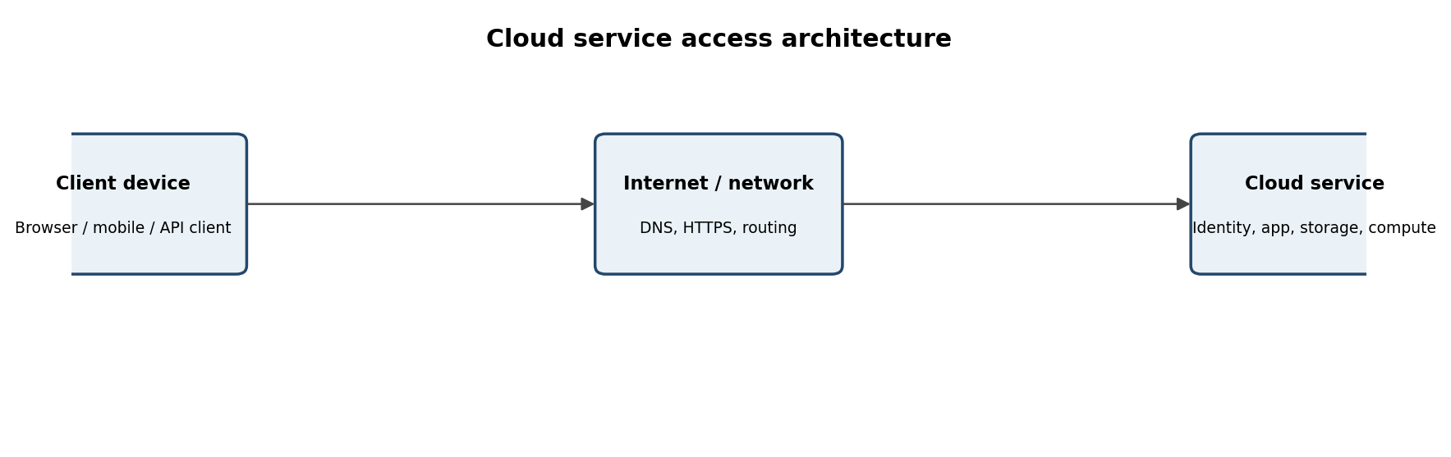
Figure 1. General cloud access path: client device → network → cloud service.
Client: The client is the device and software used by the person. It may be a laptop with a browser, a smartphone with a Drive application, or a computer running an API client. The client accepts user input, prepares requests, displays responses and may temporarily cache data.
Network: The network carries requests and responses between the client and the cloud. DNS helps locate the provider's service, IP routing moves packets, and HTTPS protects communication in transit using TLS. A stable connection improves responsiveness. A weak or interrupted connection may delay uploads, interrupt synchronization or prevent sign-in.
Cloud service: The provider operates the application, identity service, storage infrastructure and supporting systems in data centres. The service checks identity and permissions, processes the requested action and returns the result. The user normally does not manage the underlying physical servers.
1.4. Hardware and software requirements
Client hardware: laptop/desktop or smartphone/tablet; sufficient memory and storage; working display and input devices; a camera only if scanning/uploading photographs is required.
Client software: updated Chrome, Edge, Firefox or Safari; or the official Google Drive mobile app. An API demonstration may use Python 3 and the requests library.
Network: Wi-Fi, Ethernet or mobile data with Internet connectivity; DNS resolution; HTTPS access; adequate bandwidth for the file sizes being transferred.
Account and permissions: a valid account, sign-in credentials and access rights to the selected folder or file.
Security: device screen lock, updated operating system/browser, and multi-factor authentication where available.
1.5. How a user accesses Google Drive
Connect the device to the Internet and open a supported browser or the Drive mobile application.
Navigate to Google Drive or open the installed app.
Sign in using the authorized account and complete any additional identity verification requested.
Open My Drive or a shared drive/folder. The service displays only resources the account is permitted to access.
To upload, select New / Upload (or the app's plus button), choose a file and wait for the upload to complete.
To share, select the file, open Share, enter the intended collaborator's account and assign Viewer, Commenter or Editor access as appropriate.
Open the file from another authorized device to confirm that cloud synchronization makes the same resource available.
1.6. Comparison and most suitable method
Criterion | Browser access | Mobile access | API access
Ease for a general user | High | High for phone tasks | Low without technical skills
Automation | Limited manual workflow | Limited | High
Best suited for | File management and collaboration on a computer | Access while travelling and quick uploads | Integration and repeated automated operations
Main dependency | Browser + Internet | App + Internet | Code + credentials + Internet
Typical user | Student / faculty | Student / faculty on phone | Developer / system administrator

For the selected student file-sharing application, browser access is the most suitable primary method because it provides a complete interface for uploading, organizing, editing and managing permissions. Mobile access is a useful complementary method for quick access. API access is best when the task must be automated or integrated with another application, rather than for ordinary manual document editing.
7. Practical observation and limitation
A practical demonstration should compare the same Drive file on a laptop browser and a mobile device. Record the time taken to open the file, whether the file is readable, whether upload or synchronization completes, and whether sharing controls are available. A likely limitation is loss of Internet connectivity: a user may be unable to open a file that has not been made available offline, and pending changes may not synchronize until the connection returns.
EVIDENCE TO CAPTURE: Capture the Drive home page after sign-in, a file upload in progress/completed, the sharing-permission dialog, and the same file opened on a second device. Hide personal email addresses and private file names. (Insert your own genuine screenshot after performing the activity; this document does not claim that a live demonstration was performed.)
8. Result
Three access methods—browser, mobile application and API—have been identified and compared. The client–network–cloud architecture explains how requests reach the cloud service. Browser access is recommended for the selected collaborative file-storage use case, with mobile access for convenience and API access for automation.
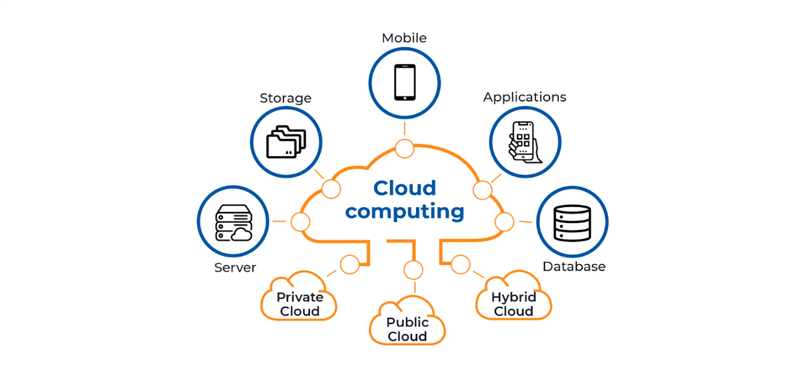

Q2 – Cloud Platforms and Web Applications
1. Selected platforms and applications
This comparison uses Google Cloud Platform (GCP) and Microsoft Azure as examples of cloud platforms. Both provide infrastructure and managed services that can host web applications. To make the comparison concrete, Google Drive is used as a Google ecosystem web application and Microsoft OneDrive is used as a Microsoft ecosystem cloud file application. The applications are not identical to the full infrastructure platforms, but they demonstrate how cloud-hosted services expose functionality to end users.
Area | Google ecosystem / GCP | Microsoft ecosystem / Azure
Platform services | Compute Engine, App Engine, Cloud Run, Cloud Storage, Cloud SQL, IAM and networking services. | Virtual Machines, App Service, Azure Functions, Blob Storage, Azure SQL, Microsoft Entra ID and virtual networking.
End-user application example | Google Drive: file storage, preview, sharing and collaborative editing with Google Workspace apps. | OneDrive: file storage, synchronization, sharing and integration with Microsoft 365 applications.
Application support | Managed compute, storage, databases, identity, monitoring and APIs can support web/mobile front ends. | Managed compute, storage, databases, identity, monitoring and APIs can support web/mobile front ends.
Identity and access | Google account / Cloud IAM according to service and organizational setup. | Microsoft account / Microsoft Entra ID and Azure role-based access control according to service.
Typical strength | Integration with Google Workspace and Google cloud services. | Integration with Microsoft 365, Windows environments and Azure services.

2. Major components of a cloud platform
Compute: virtual machines, containers, serverless functions or managed application hosting execute application logic.
Storage: object/file/block storage holds documents, images, backups and application data.
Database: relational or NoSQL databases store structured records and application state.
Networking: virtual networks, routing, load balancing, DNS and gateways connect components securely.
Identity and access management: accounts, roles and policies determine who can sign in and what each identity may do.
Monitoring and management: logs, metrics, alerts, deployment tools and billing controls help operate the service.
3. User interaction and request mapping
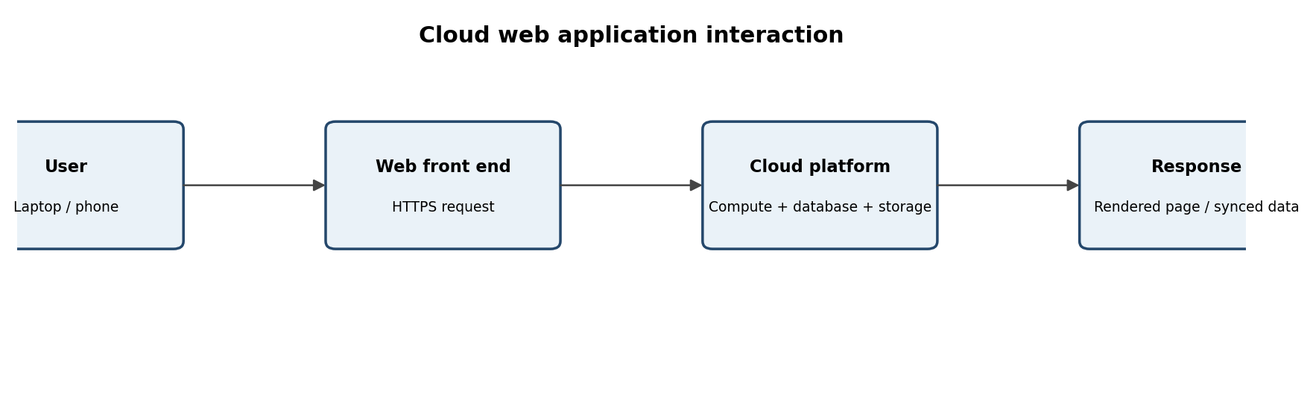
Figure 2. A typical web application request path from a user to cloud resources and back.
When a user opens a cloud web application, the browser resolves the service address and establishes an HTTPS connection. The web front end receives the request, identifies the user, and invokes the required application service. If the user opens a document, the service checks the account's access rights and retrieves the relevant metadata and file content from cloud storage. The application then returns a page or file data to the browser. For an edit, the updated content is sent back to the cloud and stored; the application may notify or synchronize other collaborators.
4. Example user action sequence: Google Drive
Open drive.google.com in a browser and sign in.
Select a folder and choose New → File upload.
Choose a sample PDF or document and wait for the upload status to complete.
Select the uploaded file and open Share.
Add a collaborator and choose Viewer, Commenter or Editor based on the task.
Open the document and make an edit or add a comment if the file type supports it.
Ask the collaborator to open the shared link while signed in with the authorized account and verify the access level.
5. Cloud resources supporting the application
A service such as Drive depends on more than a storage disk. Identity services validate the account; application servers process requests; storage systems retain files; metadata databases track names, ownership and relationships; networking transports data; and monitoring/security services support availability and protection. In a custom application hosted on GCP or Azure, a developer chooses equivalent compute, database, storage and identity services and connects them through APIs.
6. Benefits and local-only comparison
Aspect | Cloud-based application | Installed and operated only on one local computer
Access | Can be reached from multiple authorized devices over the Internet. | Normally tied to the computer or local network unless extra remote-access infrastructure is configured.
Collaboration | Multiple users can share one cloud copy with role-based permissions and version history. | Users may exchange copies manually; concurrent edits can create conflicting versions.
Maintenance | Provider manages much of the underlying infrastructure and service updates. | User or organization maintains hardware, backups, software updates and storage.
Scalability | Provider can expand capacity and services according to plan and configuration. | Limited by local hardware and the effort/cost of upgrading it.
Connectivity | Remote access depends on network and service availability. | Basic local use may continue without Internet, depending on the software and files.
Control and privacy | Data is held by a provider; users must assess policies, access controls and compliance. | Organization has more direct control over local infrastructure but must secure and maintain it.

If the same application were installed and operated only on a local computer, users could face restricted access from other devices, manual file exchange, difficult simultaneous editing, dependence on one machine, and responsibility for local backups and maintenance. A local application can nevertheless be preferable when offline operation, strict local control or low-latency processing is essential.
7. Evaluation and conclusion
Both ecosystems provide the core building blocks required to deliver web applications: compute, storage, databases, networking, identity and monitoring. Google Drive and OneDrive demonstrate how these resources become a simple user-facing service. The cloud approach improves access and collaboration, while the local-only approach can provide greater independence from Internet connectivity. Selection should consider existing organizational tools, identity management, cost, security, integration needs, data location and user familiarity.
EVIDENCE TO CAPTURE: Capture the Drive/OneDrive landing page, upload or synchronization, share dialog and a collaborator's view. If comparing platform consoles, capture only services actually opened; do not imply that a console screenshot proves a custom app was deployed. (Insert your own genuine screenshot after performing the activity; this document does not claim that a live demonstration was performed.)
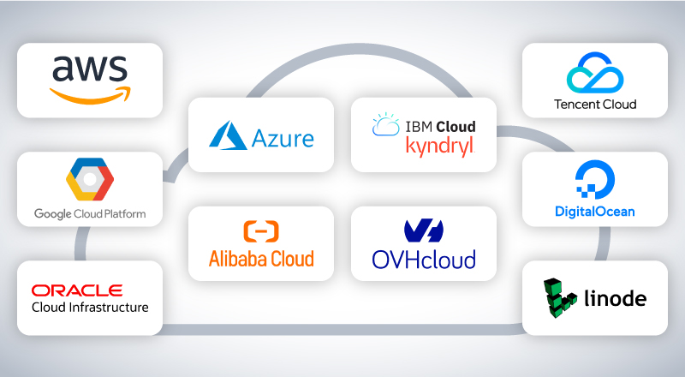

Q3 – Web APIs for Cloud Access
3.1. Meaning and purpose of a Web API
An Application Programming Interface (API) is a defined way for one software component to request data or an operation from another component. A Web API makes this interaction available over a network, commonly using HTTP or HTTPS. The client sends a request to an endpoint; the server processes it and returns a response. APIs allow a web application, mobile app or automated script to communicate with a cloud service without a person manually operating every screen.
For a simple demonstration, the public JSONPlaceholder test API is selected. It provides sample REST resources for learning and testing. The endpoint used here is GET https://jsonplaceholder.typicode.com/posts/1. This is a public demonstration service, not a private cloud-storage API and not a production database.
3.2. Request and response components
Component | Description | Example
HTTP method | Indicates the operation requested. | GET retrieves a resource.
Endpoint / URL | Address of the API resource. | https://jsonplaceholder.typicode.com/posts/1
Path parameter | Identifies a specific resource. | 1 identifies post number 1.
Headers | Carry metadata such as accepted response format or authorization. | Accept: application/json
Request body | Data sent by a client, commonly with POST/PUT/PATCH; GET usually has no body. | Not required for this GET example.
Status code | Indicates the outcome of the request. | 200 means success; 404 means resource not found.
Response body | Returned data, often JSON. | A JSON object containing userId, id, title and body.

3.3. API communication flow
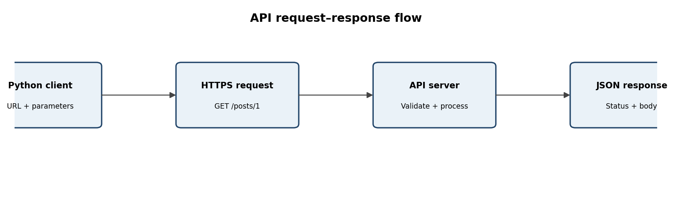
Figure 3. API client, HTTPS request, server processing and JSON response.
Client: The Python program constructs a URL and sends an HTTP request. API request: the method, endpoint, headers and optional parameters describe what the client wants. Cloud/server: the remote service receives and processes the request. API response: the service returns a status code, headers and response body. The client checks the status and converts JSON into a usable data structure.
3.4. Python implementation
Install the requests library once in the Python environment with: pip install requests. The following program sends two different GET requests: one for post 1 and one for post 2.
import requests
BASE_URL = "https://jsonplaceholder.typicode.com/posts"
def get_post(post_id):
url = f"{BASE_URL}/{post_id}"
response = requests.get(
url,
headers={"Accept": "application/json"},
timeout=15
)
print("Request URL:", url)
print("HTTP status:", response.status_code)
response.raise_for_status()
data = response.json()
print("Post ID:", data["id"])
print("User ID:", data["userId"])
print("Title:", data["title"])
print("Body:", data["body"][:100], "...")
print("-" * 50)
get_post(1)
get_post(2)
3.5. Illustrative request and response
Request 1: GET /posts/1 with Accept: application/json. Expected successful response: HTTP 200 and a JSON object with id 1, userId 1, title and body fields. Request 2: GET /posts/2 with the same method and header. Expected successful response: HTTP 200 and a different JSON object with id 2. Exact text values should be taken from the live execution output because a remote test service may change its sample data.
Test | Input / request | Expected observation | Interpretation
1 | GET /posts/1 | HTTP 200; JSON object whose id is 1. | The endpoint returns the requested sample record.
2 | GET /posts/2 | HTTP 200; JSON object whose id is 2. | Changing the resource identifier returns a different record.
Optional negative test | GET /posts/999999 | Usually HTTP 404 or an empty/not-found result depending on service behaviour. | Demonstrates why clients must handle missing resources.

3.6. Error handling and analysis
Connection error: DNS, network outage or server unavailability may prevent a response. The client should show a useful message and allow a retry.
Timeout: a request may take too long. A timeout prevents the program from waiting indefinitely.
HTTP error: 4xx codes generally indicate a client/request problem; 5xx codes indicate a server-side problem. The client should inspect the status code.
Invalid response: the server may return content that is not valid JSON. Production code should catch JSON decoding errors.
Rate limiting: a service may restrict request frequency. The client should respect retry guidance and avoid uncontrolled loops.
3.7. Why API-based access is useful at scale
When many users or applications need to communicate with a cloud service automatically, an API provides a consistent machine-readable interface. Each client can send structured requests without manually opening a browser and clicking through screens. The service can authenticate clients, validate inputs, apply permissions, log operations and return predictable responses. APIs also support integration: a student portal could call an attendance API, a mobile app could call the same backend, and a reporting service could retrieve data on a schedule. This reduces repeated manual work and supports automation and scalability.
API use does not remove the need for capacity planning or security. A large number of clients can overload an endpoint unless the service uses rate limits, caching, queues, load balancing and monitoring. Credentials must be protected, and authorization must be checked for every sensitive resource.
EVIDENCE TO CAPTURE: Run the Python program in your own IDE or terminal. Insert a screenshot showing both request URLs, status codes and returned JSON fields. Record the actual date and output; the sample descriptions above are expected behaviour, not claimed execution evidence. (Insert your own genuine screenshot after performing the activity; this document does not claim that a live demonstration was performed.)
3.8. Result
The API concept, request/response structure and client–server flow are explained. A Python client is provided for two distinct requests to a public test API. The returned status and JSON data demonstrate programmatic access and show why APIs are useful for automated cloud communication.
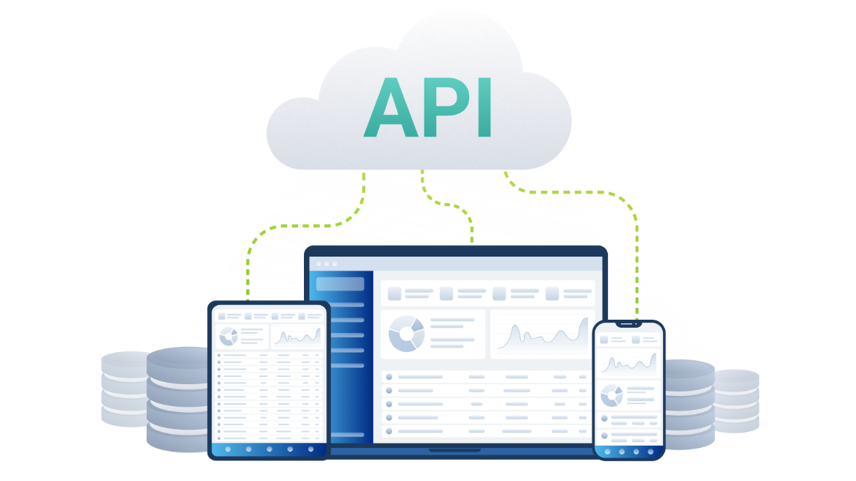

Q4 – Cloud Security and Network Access
Maximum marks: 7 | Suggested evidence: architecture, implementation record, observations and evaluation
4.1. Introduction
Cloud services are accessed through networks and may be used from many locations and devices. This improves accessibility but increases the importance of identity verification, permission control, secure communication and monitoring. A secure design must protect both the account and the data stored in the cloud. Authentication answers 'Who are you?' while authorization answers 'What are you allowed to do?'.
4.2. Secure cloud-access architecture
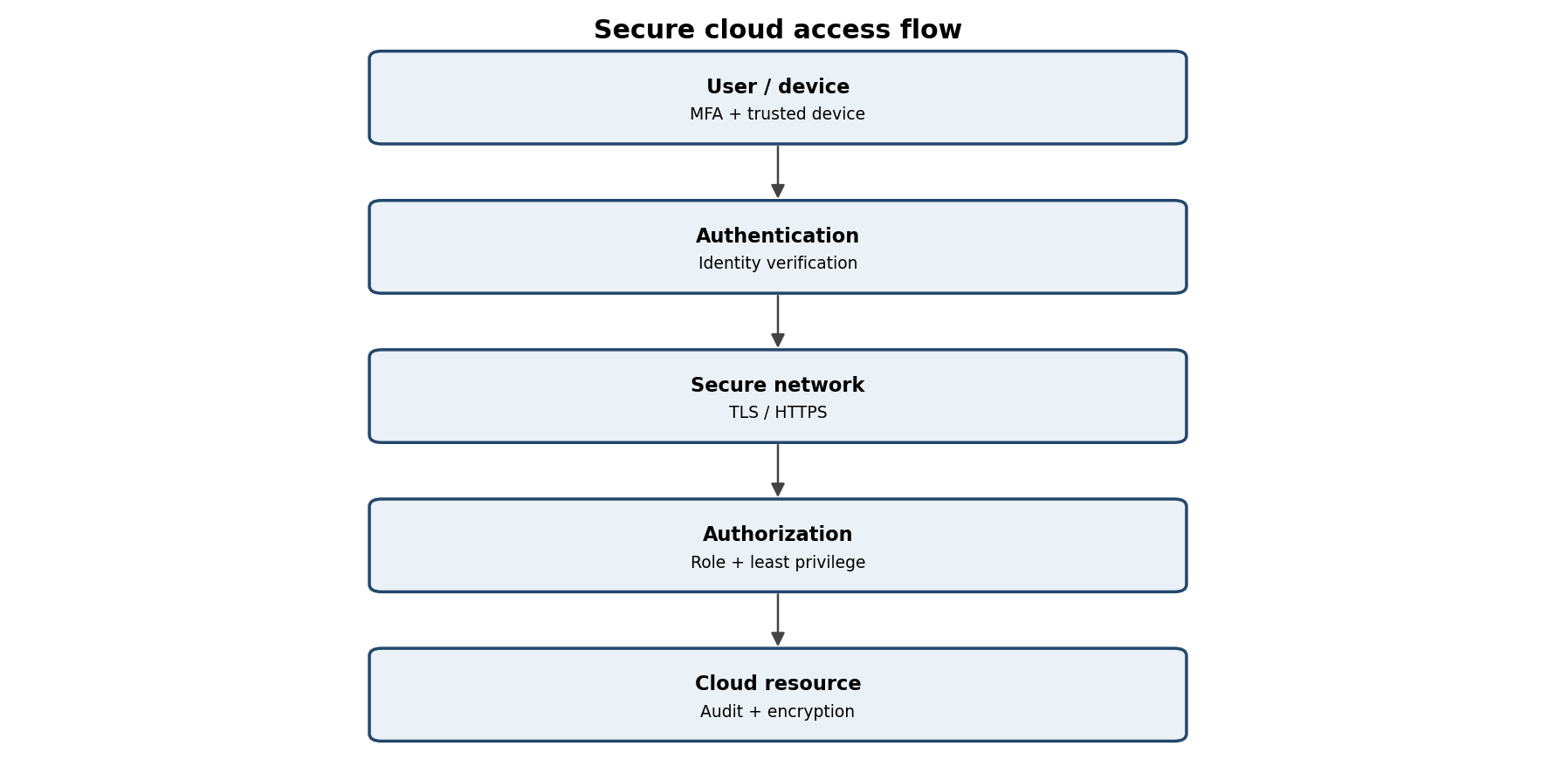
Figure 4. Secure access flow with identity verification, protected transport and authorization.

The user first signs in through the identity provider. Multi-factor authentication (MFA) adds a second proof, such as an authenticator approval. The client then communicates with the service using HTTPS/TLS. After the identity is verified, the cloud application checks authorization policies such as ownership, group membership and role. Only then is the requested resource made available. Security logs record important actions for later review.
4.3. At least four security considerations
Security consideration | Risk if neglected | Recommended measure
Authentication | An attacker may guess, steal or reuse a password and impersonate a user. | Use strong unique passwords, MFA, secure recovery methods and account alerts.
Authorization / least privilege | A user may view, modify or delete data beyond their responsibility. | Assign Viewer/Commenter/Editor roles carefully; grant only the minimum required access; review permissions.
Secure communication | Data may be intercepted or altered on an untrusted network. | Use HTTPS/TLS; avoid entering credentials on suspicious pages; validate certificates; use trusted networks.
Data protection | Lost or exposed files may reveal personal or institutional information. | Use encryption at rest where supported, data classification, controlled sharing, backups and retention policies.
Device and session security | An unlocked or infected device may expose an active cloud session. | Keep devices updated, enable screen lock, use endpoint protection, sign out on shared devices and revoke lost-device sessions.
Monitoring and recovery | Suspicious access may go unnoticed; accidental deletion may be permanent. | Enable audit logs/alerts, review activity, maintain version history and tested backups.

4.4. Authentication and authorization
Authentication verifies identity. A typical process uses a username and password, followed by MFA. The service may issue a session or access token after successful verification. Authorization is a separate check performed when the user requests a resource. For example, a student may be authenticated successfully but still be denied access to another group's private folder. The application should return an access-denied response rather than disclose the protected content.
4.5. Possible attack points and mitigations
Attack point / threat | Possible effect | Mitigation
Phishing page or fake sign-in link | Credentials and MFA approval may be stolen. | Check domain names, use MFA, report suspicious messages and use password managers.
Weak or reused password | Account takeover through guessing or credential stuffing. | Unique long passwords, MFA, login alerts and breached-password checks.
Public/untrusted Wi-Fi | Traffic interception or fake access points may target users. | HTTPS/TLS, avoid unknown networks for sensitive work, use institution-approved VPN where required.
Over-shared folder/link | Unauthorized people may read or change documents. | Restrict to named accounts, set Viewer by default, disable public links where possible and review access.
Compromised endpoint | Malware or a stolen device may use an active session. | Patch software, screen lock, endpoint protection, device encryption and remote session revocation.
Misconfigured API credentials | A leaked key/token may permit unauthorized operations. | Store secrets securely, scope permissions, rotate/revoke credentials and never commit secrets to source code.

4.6. Practical scenario: shared assignment folder
A pair of students creates a cloud folder for an assignment. Each student signs in with an individual account and MFA. The folder is shared only with the partner and the faculty member. Both students receive Editor access only where they need to contribute; the faculty member may receive Commenter or Viewer access depending on the evaluation requirement. The link is not set to 'Anyone with the link'. HTTPS protects communication between the browser and service. Version history and audit activity help identify accidental changes.
4.7. Secure versus insecure access
Secure situation | Insecure situation
Student signs in on the official service domain with MFA. | Student follows an unknown link and enters credentials into a look-alike page.
Folder is shared with named accounts and least privilege. | Folder is public or shared with Editor permission to everyone.
User signs out and locks a shared computer. | User leaves an active cloud session open on a public computer.
Sensitive files are stored in approved cloud locations with access review. | Sensitive data is uploaded to an unknown personal account.

4.8. Joint evaluation
Because cloud access is available from many places over the Internet, the system must assume that devices and networks may be untrusted. Compared with a local application, additional controls are needed for remote identity verification, session management, secure transport, link sharing, device security and continuous monitoring. Poor security can cause data leakage, unauthorized edits, loss of trust, academic disruption and possible institutional consequences. A secure cloud design therefore combines authentication, authorization, encryption, least privilege, monitoring and user awareness.
EVIDENCE TO CAPTURE: For evidence, capture MFA/security settings without exposing recovery codes, the named-user sharing dialog, and a permission-denied test using an account that should not have access. Do not display passwords, tokens or private student information. (Insert your own genuine screenshot after performing the activity; this document does not claim that a live demonstration was performed.)
4.9. Result
The secure access flow and six security considerations have been identified. Threats are mapped to mitigations, and a shared assignment folder demonstrates how authentication, authorization and secure network communication work together.

Q5 – Collaboration Using Cloud-Based Services
5.1. Selected collaboration platform and requirements
Google Drive with Google Docs is selected as the cloud collaboration service. The goal is for two students to prepare one assignment document without repeatedly sending separate copies by email or messaging. The shared document is stored in the cloud and can be accessed by authorized users from different devices. The workflow requires a shared workspace, clear roles, concurrent editing, version history and a method to review contributions.
5.2. Collaboration workflow
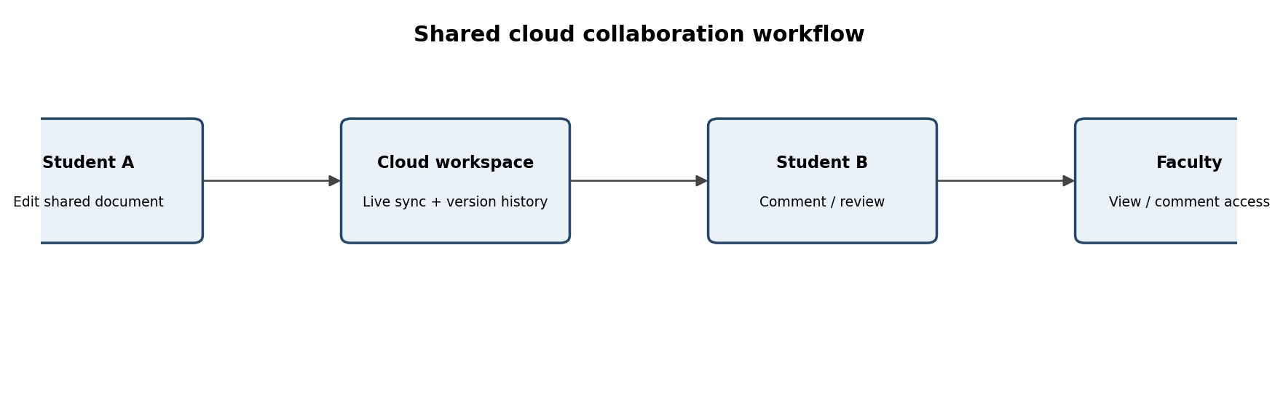
Figure 5. One shared cloud workspace supports editing, review and faculty access.
Student A creates a folder named for the assignment in the institutional or approved Google account.
Student A creates a Google Doc inside the folder and adds the assignment title and section headings.
Student A shares the folder or document with Student B using the partner's correct account.
Student A assigns Editor access to Student B because both students contribute content. The faculty member is given Commenter or Viewer access as required.
Student A and Student B open the same document and work on separate sections or use comments to coordinate changes.
Both students review the document, resolve comments and check version history before submission.
At the end, the pair verifies that only intended users retain access and exports the final document if a DOCX/PDF copy is required.
5.3. Collaboration concepts
Concept | Meaning | Application in the assignment
Sharing | Making a cloud resource available to selected identities or groups. | The document owner invites the partner and faculty member.
Concurrent access | More than one authorized user can open the same resource at the same time. | Student A writes the introduction while Student B edits the comparison section.
Version control | Maintaining earlier versions or a history of changes so edits can be reviewed or restored. | The pair checks version history after a major revision and restores a version if necessary.
Permission management | Assigning roles that determine whether a user can view, comment or edit. | Students receive Editor access; faculty receive the minimum access needed for review.

5.4. User roles and permission justification
Role | Suggested permission | Reason
Student A – document owner | Owner / Editor | Creates the workspace, controls sharing and contributes content.
Student B – partner | Editor | Must add and revise assignment content collaboratively.
Faculty evaluator | Commenter or Viewer | Can inspect the submission and provide feedback without unnecessary editing rights.
Other students | No access unless explicitly required | Prevents accidental disclosure or modification.

Editor permission should be limited to the two students who are responsible for preparing the document. If the faculty member only needs to assess the work, Viewer or Commenter is safer than Editor. Public link access should be avoided for work containing student details or unpublished assignment content.
5.5. Two collaborative activities and expected observations
Activity | Procedure | Evidence / observation to record
Activity 1: simultaneous editing | Student A adds a paragraph while Student B adds a table or edits another section in the same document. | Both edits appear in the shared document; note whether updates appear without manual file transfer.
Activity 2: comment and resolve | Student B highlights a sentence and leaves a comment; Student A replies, revises the text and resolves the comment. | Comment thread shows feedback and resolution; record how the pair coordinated.
Additional check: permission test | A user without permission attempts to open the shared link. | The service should require sign-in and deny access if the identity is not authorized.

6.6. How cloud collaboration avoids multiple file copies
Cloud collaboration reduces the need to exchange multiple copies because all authorized participants work on one shared cloud resource. Instead of Student A editing 'assignment_final.docx' and Student B editing 'assignment_final_latest.docx', both can work on the same document. The service synchronizes changes, maintains version history and provides comments. This reduces confusion about which file is current and lowers the risk of merging incompatible edits manually.
6.7. Collaboration issues and solutions
Accidental overwrite or deletion: use version history, restore an earlier version and agree on section ownership.
Conflicting edits or unclear responsibility: use comments, headings and a simple task allocation record.
Incorrect permission: change the role immediately, remove unintended users and review the access list.
Network interruption: wait for synchronization to resume, avoid closing unsaved work and verify the latest version after reconnecting.
Privacy exposure: avoid public links and share only with named accounts.
6.8. Problems caused by incorrect sharing permissions
If Editor access is given too widely, a person may alter or delete content, change sharing settings or introduce incorrect information. If Viewer access is given to a student who must contribute, the collaboration process is blocked. If a document is shared publicly, confidential student or institutional information may be exposed. Permission settings should therefore match the person's task and be reviewed before submission.
EVIDENCE TO CAPTURE: Capture the shared document with both users' contributions, the Share dialog showing roles, a comment thread and version history. Use test content and hide personal account details. The two students should each record what they actually contributed. (Insert your own genuine screenshot after performing the activity; this document does not claim that a live demonstration was performed.)
6.9. Result
A cloud collaboration workflow is designed using a shared Google Docs workspace. Sharing, concurrent access, version control and permission management are explained, and two collaborative activities are specified with evidence to capture.

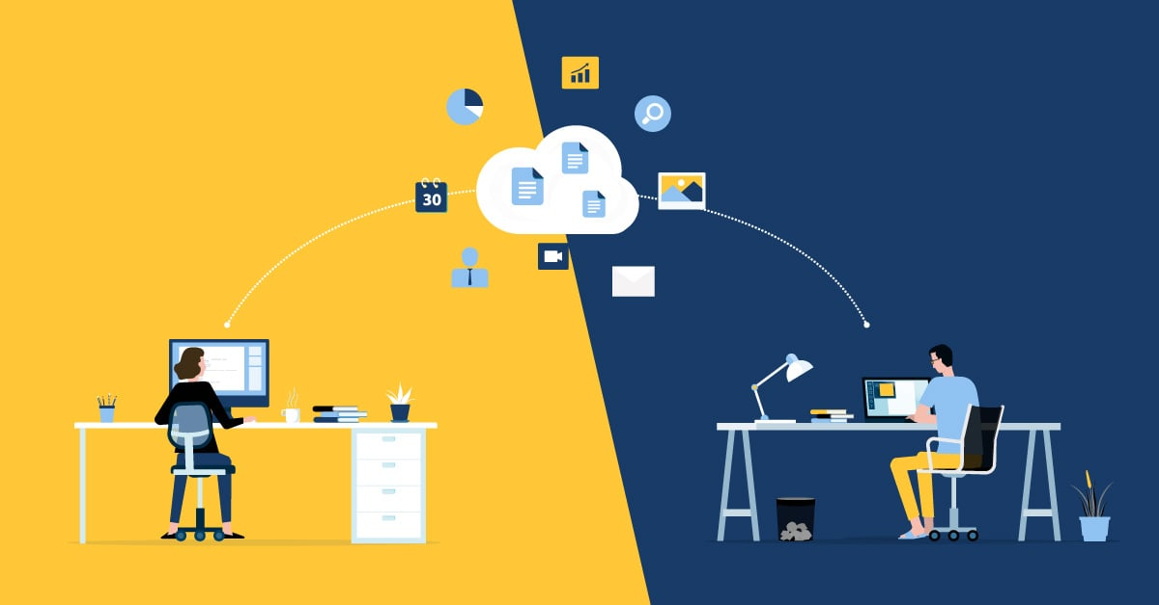

Q6 – Integrated Cloud Access and Collaboration Mini Investigation
6.1. Selected scenario and problem definition
Scenario selected: Cloud-Based Assignment Submission and Evaluation. In a conventional process, students may submit files through email or messaging. Faculty members may receive duplicate files, lose track of revisions and manually communicate feedback. A cloud-based system can provide a central submission location, track status and allow faculty to review work collaboratively.
6.2. Users and requirements
User | Main activities | Access requirement
Student | Sign in, upload assignment, view submission status, read feedback and resubmit if permitted. | Browser or mobile application; access only to own submission and shared course resources.
Faculty | Create assignment, view submissions, add comments/marks, update status and communicate feedback. | Browser; access to submissions for assigned courses.
Administrator | Manage accounts, course membership, retention and system settings. | Restricted administrative console with stronger controls.

6.3. Required cloud services
Web application hosting: serves the student and faculty interfaces.
Identity and authentication: verifies student/faculty accounts and supports role-based authorization.
Cloud object storage: stores uploaded assignment files and feedback attachments.
Database: stores assignment details, deadlines, user/course mapping, submission metadata and status.
Web API: allows the front end to upload files, retrieve status and submit feedback through defined endpoints.
Logging and monitoring: records upload/review activity and helps identify errors.
Backup/versioning: supports recovery from accidental deletion or unwanted changes.
6.4. System architecture
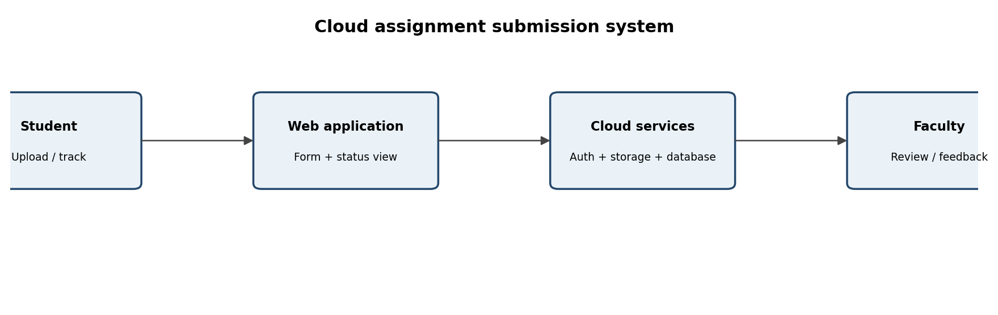
Figure 6. Assignment submission and evaluation system architecture.
A student or faculty member uses a browser or mobile device to connect over HTTPS. The web application authenticates the user and checks the user's role. A student can upload a file to cloud storage and the application records the submission metadata in a database. Faculty can retrieve submissions for their course, review the file and enter feedback. The application stores feedback and updates the status so the student can view it.
6.5. Main workflow
Faculty signs in and creates an assignment with title, instructions, due date and allowed file types.
Student signs in and views only assignments available to the student's course or group.
Student selects an assignment, uploads the file and confirms submission.
The application validates file type and size, stores the file in cloud storage and records a timestamp and status in the database.
Faculty signs in, opens the course submission list and reviews the uploaded file.
Faculty adds comments or marks and changes the status to Reviewed.
Student opens the feedback page and reads the comments. If resubmission is enabled, the student uploads a revised version.
The system maintains submission history and audit records.
6.6. Prototype / mock-up specification
Screen | Key elements | Expected action
Login | Institutional identity, password/MFA, role detection. | Authenticate user and route to student or faculty dashboard.
Student dashboard | Course, assignment title, due date, status and Upload button. | Select an assignment and submit a file.
Submission confirmation | File name, upload time, confirmation ID and current status. | Confirm that the file was received.
Faculty dashboard | Course filter, student list, submission status and Review action. | Open a submission and provide feedback.
Feedback view | Faculty comments, marks if applicable, reviewed date and resubmission status. | Student reads feedback and acts on it.

6.7. Two user test scenarios
Test case | Steps | Expected result | Actual result field
Test 1 – Student submission | Student signs in, selects an open assignment, uploads an allowed PDF and confirms. | File is stored; submission record is created; status becomes Submitted; confirmation is displayed. | To be completed by students: __________________
Test 2 – Faculty review and student feedback | Faculty signs in, opens the course submission, comments and marks it Reviewed; student signs in again. | Faculty can access the correct course submission; feedback is saved; student can view feedback but cannot edit faculty-only fields. | To be completed by students: __________________
Negative test – unauthorized access | A student attempts to open another student's submission URL. | Access is denied and the event may be logged. | To be completed by students: __________________

6.8. Evaluation: efficiency, limitations and improvements
Combining cloud access and collaboration improves efficiency because students can submit from different devices, faculty can review from an authorized location, and feedback is stored alongside the relevant submission. A central record reduces duplicate email attachments and makes status visible. Role-based access prevents students from viewing other students' work. Version history can preserve resubmissions and make the review process traceable.
Limitations include dependence on Internet connectivity, storage and bandwidth limits, service downtime, file-format compatibility, account-management errors and privacy risks. Large files may take time to upload. Users may also need training. Improvements include resumable uploads, clear file-size limits, notifications, accessible mobile design, audit logs, backups, encryption, multi-factor authentication and a documented recovery process.
6.9. Joint evaluation answer
The combination of cloud access and collaboration makes the proposed system more efficient by providing a single, remotely accessible workflow for submission, review and feedback. Cloud access makes the system available to authorized students and faculty, while collaboration features allow comments, shared records and coordinated evaluation. The system reduces manual file exchange and improves traceability, provided that connectivity, permissions, security and service availability are managed.
EVIDENCE TO CAPTURE: Build a simple mock-up in Google Forms/Sheets, a shared Drive folder, or a small local prototype connected to a cloud service. Capture a student submission view and faculty review view. Perform both tests and fill in the actual-result column; do not leave it as an assumed pass. (Insert your own genuine screenshot after performing the activity; this document does not claim that a live demonstration was performed.)
6.10. Result
A cloud-based assignment submission and evaluation scenario is designed with users, cloud services, architecture, workflow, prototype screens and two user tests. The design combines remote cloud access with collaborative review and identifies practical limitations and improvements.

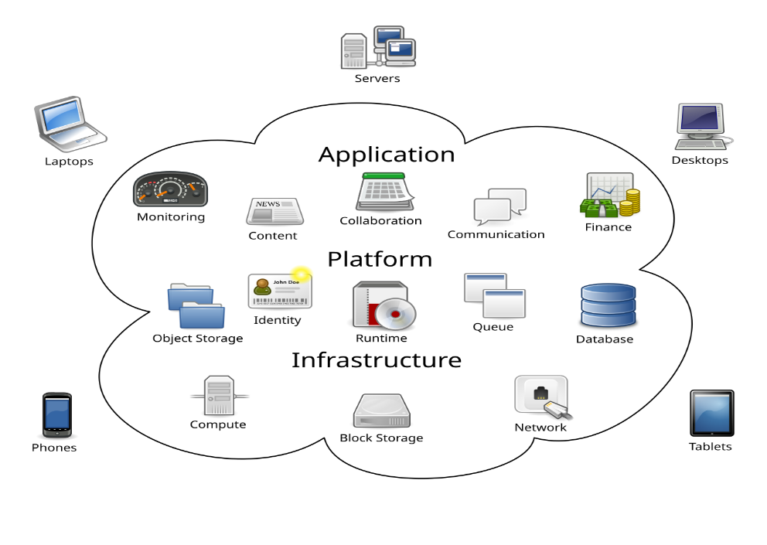

Q7 – Day-4 Design Challenge: Cloud-Based Collaborative Solution
7.1. Problem and proposed solution
The pair proposes a Cloud-Based College Project Coordination System. Student teams often need to share project documents, divide tasks, record progress and receive faculty guidance. When information is exchanged through separate messages and file copies, members may work on outdated versions or miss updates. The proposed system provides one cloud workspace for project files, tasks, comments, milestones and faculty review.
7.2. Stage 1 – Independent design proposals
Student A – initial proposal
Problem definition: student teams need a reliable place to store project documents and coordinate task progress. Target users: team members, team leader and project guide. Access method: browser-based access as the primary method, with mobile access for notifications and quick updates. Required cloud services: web application hosting, object storage, database, identity service and notification service. Collaboration mechanism: shared project folder, task board, comments and version history. Basic architecture: student browser → Internet/HTTPS → cloud web application → project database and file storage → authorized team members and guide.
Student B – initial proposal
Problem definition: project updates and approvals are delayed because status information is spread across messages and local files. Target users: students, faculty guide and department coordinator. Access method: browser and mobile app, with a REST API for status updates and notifications. Required cloud services: managed application hosting, API gateway, database, object storage, identity and audit logging. Collaboration mechanism: role-based shared workspace, concurrent document editing, milestone approvals and activity feed. Basic architecture: user device → secure network → identity/API layer → cloud project service → shared task records and documents.
7.3. Stage 2 – Design comparison record
Comparison area | Student A proposal | Student B proposal | Joint decision
Problem emphasis | Shared project documents and task progress. | Delayed updates and approval visibility. | Combine document management with task and approval tracking.
Target users | Team members, leader, guide. | Students, guide, coordinator. | Students, team leader, faculty guide; coordinator as optional admin.
Access method | Browser primary; mobile notifications. | Browser + mobile + REST API. | Browser first, mobile-friendly interface, API for integrations.
Cloud services | Hosting, storage, database, identity, notifications. | Hosting, API gateway, database, storage, identity, audit. | Use managed hosting, database, object storage, identity, API and logs.
Collaboration | Shared folder, task board, comments, versions. | Workspace, milestones, approvals, activity feed. | Combine shared files, task board, comments, version history and approvals.
Main strength | Simple and easy to demonstrate. | Better integration and traceability. | Retain simplicity while adding controlled API and audit capability.
Potential weakness | Less detail about API and audit controls. | More components to configure and maintain. | Use a minimal architecture and add components only when required.

7.4. Stage 3 – Joint final design
Final solution: a web-based project workspace in which each project has a member list, task board, milestone schedule, shared file area and faculty feedback section. Users sign in individually. The system applies role-based access so students can update their own project, the guide can review and comment, and an administrator can manage membership and service configuration.
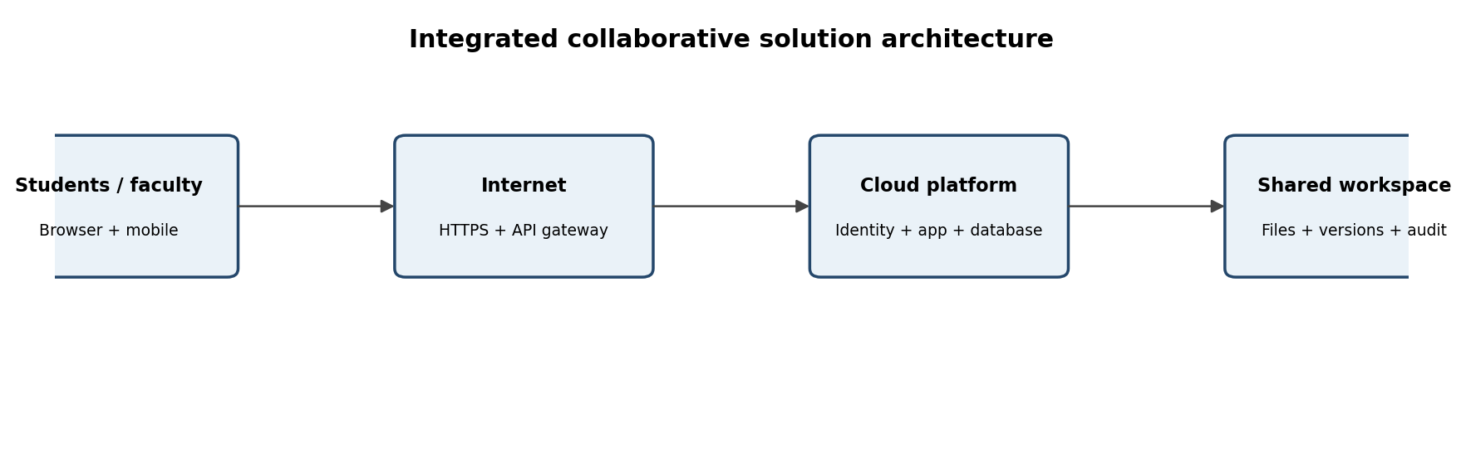
Figure 7. Joint architecture for the cloud-based college project coordination system.
7.5. Final design components
Component | Selected design | Purpose
Client | Responsive web browser on laptop/phone. | Provides access without requiring a special desktop installation.
Network | Internet with HTTPS/TLS. | Carries protected requests and responses.
Identity | Institutional sign-in, MFA where available and session control. | Verifies users and reduces account misuse.
Application | Managed cloud web application and REST API. | Implements project, task, milestone and review functions.
Database | Managed relational database. | Stores project membership, tasks, deadlines, status and comments.
File storage | Cloud object/file storage with versioning where supported. | Stores reports, images, source files and presentation documents.
Collaboration | Shared workspace, comments, task assignment and version history. | Keeps team activity in one place.
Monitoring | Application logs, access audit and service alerts. | Supports troubleshooting and accountability.

7.6. Complete system workflow
Project leader creates a project and enters its title, objective, members and faculty guide.
Each member signs in and sees only projects to which the member belongs.
The leader creates tasks, assigns owners and sets target dates.
Members update task status and attach relevant documents to the shared project space.
Collaborators comment on documents or tasks and use version history to review changes.
The faculty guide opens the project, reviews milestones and provides comments or approval.
The system records important actions, such as membership changes, uploads and status updates.
At completion, the team exports the final report and the administrator applies the institution's retention policy.
7.7. Authentication, authorization and data sharing
Authentication verifies the identity of each student and faculty member. MFA should be enabled where the institution supports it. Authorization uses roles: Student Member can view project information, edit assigned tasks and upload project files; Team Leader can manage task assignments and invite approved members; Faculty Guide can view assigned projects and add review comments; Administrator can manage accounts and configuration. Access to a project is limited to its members and assigned guide. Public sharing links are disabled by default.
7.8. API requirement and example operations
API operation | Example endpoint | Purpose / access rule
List my projects | GET /api/projects | Returns projects for the authenticated user only.
Create a task | POST /api/projects/{projectId}/tasks | Team leader or authorized member creates a task.
Update task status | PATCH /api/tasks/{taskId} | Assigned member updates status; server validates membership.
Upload a file | POST /api/projects/{projectId}/files | Authorized project member uploads a file; storage reference is saved.
Add review comment | POST /api/projects/{projectId}/comments | Project member or guide adds a comment according to role.

The API should validate input, check the user's identity and project membership, enforce file-size/type limits, return appropriate HTTP status codes and record important actions. Tokens and secrets must not be stored in public source code.

7.9. Stage 4 – Validation plan
Test ID | User / condition | Action | Expected behaviour | Evidence to record
T1 | Student member | Sign in and open an assigned project. | Project dashboard is displayed; unrelated projects are hidden. | Screenshot of dashboard with private data masked.
T2 | Student member | Upload a permitted project file and update a task. | File appears in the project area; task status is updated for authorized members. | Upload confirmation and task status screenshot.
T3 | Faculty guide | Open assigned project and add a review comment. | Guide can review assigned project and comment; student can see feedback. | Guide review screen and student feedback view.
T4 | Unauthorized student | Attempt to open a project outside membership. | Request is denied; no project data is disclosed. | Access-denied result or sanitized log.
T5 | Network interruption | Disconnect during an upload and reconnect. | Application reports failure or resumes safely; no false success is shown. | Observed behaviour and recovery notes.

7.10. Student A – technical validation
Student A should explain why browser access was selected, how HTTPS carries the request, why managed hosting and cloud storage are suitable, how the API connects the front end to application logic, and how role checks protect project data. The technical validation should also consider whether the selected platform supports expected storage, user count, integration, backups and monitoring.
7.11. Student B – experimental validation
Student B should prepare the test cases, run them using at least two user roles and record actual observations. Expected behaviour must be compared with what the prototype actually does. If a feature is only represented in a mock-up and is not connected to a working service, it must be described as a mock-up rather than a completed implementation.
7.12. Stage 5 – Cross-defence
Student A: Experimental evidence supporting the design includes successful sign-in, a project dashboard restricted to the correct member, a file upload confirmation, an updated task status, a faculty comment and an access-denied result for an unauthorized user. These results should be attached as genuine screenshots or logs after the tests are performed.
Student B: The browser and mobile-friendly approach was selected because students and faculty use different devices and need convenient access. Cloud collaboration was selected because one shared workspace, task records, comments and version history reduce duplicate files and keep project communication connected to the work. The API supports repeatable communication between the interface and cloud services.
7.13. Stage 6 – Joint evaluation
Evaluation factor | Benefit / risk | Design response
Benefits | Shared files and tasks improve visibility and coordination. | One project workspace with clear ownership and status.
Access limitations | Internet outage, slow bandwidth or provider downtime can interrupt use. | Responsive interface, clear error messages, backup/export and recovery plan.
Collaboration | Comments, shared documents and version history reduce duplicate copies. | Role-based workspace and activity history.
Security risks | Account compromise, oversharing, malicious uploads or leaked tokens. | MFA, least privilege, HTTPS, file validation, audit logs and secret management.
Scalability | More projects and users increase storage, database and API load. | Managed services, quotas, monitoring, caching and capacity review.
Improvements | Notifications, calendar integration, mobile app and analytics could improve usability. | Prioritize based on user feedback and institutional requirements.
Unsuitable situations | A cloud solution may be unsuitable where reliable connectivity is unavailable or data must remain on an isolated local network. | Consider offline-first or on-premises alternatives, subject to policy.

7.14. Final question – characteristics to consider
Before selecting cloud-based access and collaboration for a real-world application, a designer should evaluate user needs, device diversity, network reliability, data sensitivity, authentication and authorization requirements, collaboration patterns, integration/API needs, storage and compute demand, scalability, availability, backup and recovery, cost, provider dependency, compliance and ease of use. The designer should also identify whether users need offline operation and what happens during service interruption. The best design is not necessarily the one with the most cloud components; it is the simplest design that safely meets the real requirements and can be tested.
7.15. Result
Two independent proposals have been recorded, their differences and strengths have been compared, and a joint cloud-based project coordination design has been produced. The design includes architecture, access, API operations, collaboration, security and validation tests. The final prototype must be demonstrated and the expected-versus-observed results completed by the pair.

Contribution Record

Question | Student A – primary contribution | Student B – primary contribution | Joint work
Q1 | Classify access methods; prepare access architecture and suitability explanation. | Demonstrate access, capture screenshots and record device observations. | Select Drive; compare browser, mobile and API access; cross-explain.
Q2 | Analyse platform components and prepare interaction diagram. | Demonstrate selected web application and record user actions. | Compare cloud and local-only operation.
Q3 | Explain API purpose, request/response and communication flow. | Implement Python client, execute two requests and capture outputs. | Analyse results and usefulness at scale.
Q4 | Investigate scenario and compare secure/insecure access. | Prepare security design, threats and mitigations. | Evaluate Internet-facing security requirements.
Q5 | Design workspace, roles and permission workflow. | Perform collaborative edits, comments and permission demonstration. | Review version history and collaboration issues.
Q6 | Define scenario, users, services and architecture. | Prepare prototype/workflow, run user tests and record results. | Evaluate efficiency, limitations and improvements.
Q7 | Prepare independent proposal and technical validation. | Prepare independent proposal and experimental validation. | Compare proposals, make joint design, test and defend decisions.

